MENTAL WELLNESS AND ADDICTIONS RECOVERY FUNDS
REPORTING FORM
2026-2027

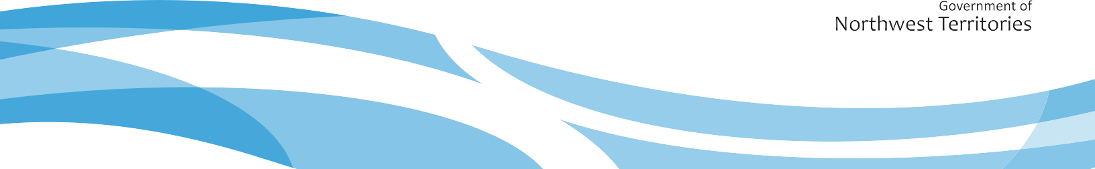

Identification
Contact Name:
Organization Name:
Phone Number: |  | Email:
Mailing Address: (Apartment, street, or P.O Box – if applicable)

Community | Territory  NT |  | Postal Code

Funding Information
Select the fund you are reporting on:

☐Community Suicide Prevention Fund
☐Mental Wellness and Addictions Recovery Fund

For fund requirements, visit: www.hss.gov.nt.ca/funding

Reporting Instructions
- If you received funding for several different projects, submit a separate report for each project.
- Submit paper reports by email to mha@gov.nt.ca.
- To complete an online report, click Mental Wellness and Addictions Recovery Funds Reporting Form 2026-2027 – Fill out form
- For questions, contact mha@gov.nt.ca .

Program Information
Program Title(s):

Program Description
Please provide concise, clear answers. Maximum word count applies where indicated.
- Location(s) of program(s)/activities:
- Date(s) of the program(s)/activities:
- Activity(ies) delivered:
- Target audience (i.e., age, gender, demographics, special consideration such as mental health and addictions challenges, etc.):
- How did the program(s)/activities link to mental wellness, addictions recovery, or harm reduction? (max 150 words)

Program Evaluation
- What worked well with program(s)/activities? (max 150 words)
- What, if anything, did not go as planned? (max 150 words)

- If you could run the program(s) again, is there anything you would do differently?
(max 150 words)
- Attendance at program(s)/activities:
(each person is counted once, separate by gender if possible)
Number of Attendees
Women
Men
Total People

- Did community partners contribute to the program(s)/activities?
☐Yes ☐No
- If yes, what value or added benefit did they bring to the program(s)/activities?
(max 150 words)

Program Results
- Do you feel the program(s)/activities had a positive impact on the community?
☐Yes ☐No
- Please describe the community impact:
(max 150 words)
- Did you collect feedback from participants?
☐Yes ☐No
- If yes, please describe the feedback received:
(max 150 words)

Feedback
- Please rate your satisfaction with the funding process:
☐Very Satisfied
☐Satisfied
☐Neutral
☐Dissatisfied
☐Very Dissatisfied
- What worked well or did you like about the funding process?
(max 150 words)
- Please share any challenges with the funding process:
(max 150 words)

Financial Report
Please submit a separate financial report for each fund that you accessed.
Note: For agreements valued at $250,000 or greater per year, Audited Financial Statements must be submitted separately, per the terms of the funding agreement.

Declaration
This information collected in this report is under the authority of the Access to Information and Protection of Privacy Act (ATIPP), section 40(c)(i), the Health Information Act (‘HIA’), and the associated Regulations. It will be used to monitor the Mental Wellness and Addictions Recovery Funds and programs and for their general administration and enforcement.
The privacy provisions of ATIPP and the HIA protect this information. I understand that the information provided in this application may be accessed under ATIPP and HIA. Questions regarding the collection, use, or disclosure of personal or health information may be directed to the Mental Wellness and Addictions Recovery Division at mha@gov.nt.ca.
I certify that the information provided is accurate, complete, and that reporting is fairly presented.
Signature: ________________________________________________

Name (Printed): __________________________________________________________________

Title/Position of spending authority: _____________________________________________________

Date of signature (day/month/year): _____________________________________________

Submission Instructions
- Submit paper reports by email to mha@gov.nt.ca.
- To complete an online report, click Mental Wellness and Addictions Recovery Funds Reporting Form 2026-2027 – Fill out form
- For questions, contact mha@gov.nt.ca .

