MENTAL WELLNESS AND ADDICTIONS RECOVERY FUNDS
APPLICATION FORM
2025-2026

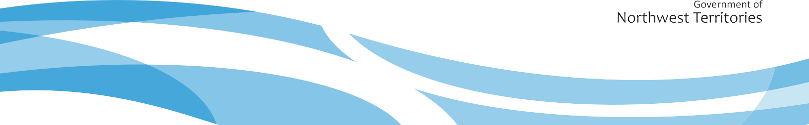

Table of Contents
Identification 2
Funding Information 2
Program Information 3
Budget 4
Declaration 4

Identification
Contact Name:
Organization Name:
Phone Number: |  | Email:
Mailing Address
Apartment, Street Number and Name, P.O Box

Community | Territory  NT |  | Postal Code

Funding Information
Please identify which fund you are applying for (Please check all that apply):

☐ Community Suicide Prevention Fund | ☐ Mental Wellness and Addictions Recovery Fund

For more information about the specific requirements of each fund please visit:
- www.hss.gov.nt.ca/funding

APPLICATION INSTRUCTIONS
- If you are applying to multiple funds to support the same project:
  - Please ensure that your proposal clearly identifies linkages between each of the fund mandates and your project.
  - Please used the provided budget template.
- If you are applying for a number of different projects:
  - Please complete a separate application form and budget for each project.

If you have any questions please reach out to us at mha@gov.nt.ca

Program Information

Program Title

Program Description
Describe what you have planned, and what you plan to do. Include location of your program, dates, and target groups (e.g., age and gender).

Program Evaluation
Describe how your program will make a difference. Include what you want to accomplish.

Community Partnership
Describe the community partnership and the number and type of supports provided by them to enhance the delivery of the program.

Budget
Please detail how much you anticipate spending on each budget line item. Please use the attached excel spreadsheet for your proposed budget.

Declaration
This information is being collected under the authority of the Access to Information and Protection of Privacy Act (ATIPP), section 40(c)(i), the Health Information Act (‘HIA’), and the associated Regulations. The information will be used for the purposes of monitoring the Mental Wellness and Addictions Recovery Funds and programs and for the general administration and enforcement of these funds and programs.
The privacy provisions of ATIPP and the HIA protect this information, and I understand the information provided in this application may be accessible under ATIPP and HIA. Any questions relating to the collection, use, or disclosure of personal (health) information on this form may be directed to the Mental Wellness and Addictions Recovery Division by emailing mha@gov.nt.ca.
I certify that the information given is accurate and complete, and that the reporting is fairly presented.
Signature: ________________________________________________

Name (Printed): __________________________________________________________________

Title of spending authority: _____________________________________________________

Date of signature (day/month /year): _____________________________________________

Send completed applications to: mha@gov.nt.ca or Fax: (867) 873-7706.

