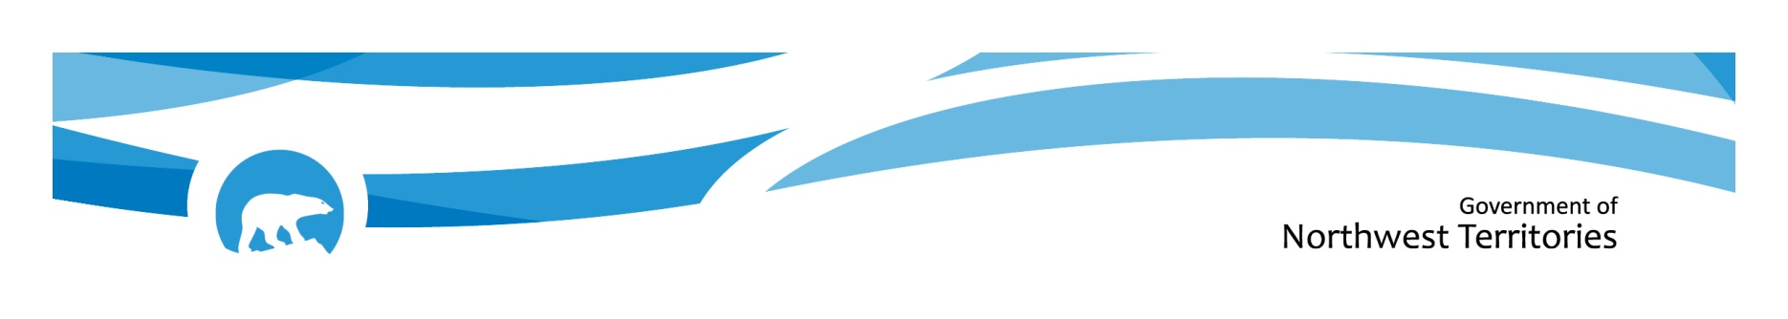

GNWT ACCESSIBILITY AND INCLUSION AWARD
The GNWT Accessibility and Inclusion Award is presented to an individual in recognition of their contribution to making the Northwest Territories a more accessible and inclusive territory. The individual must be a resident of the Northwest Territories and can be nominated by anyone.
Please submit nomination forms to: AIPWD_Award@gov.nt.ca
The Award will be presented at an event to be held during the week of May 25 to May 31, 2025, to align with National AccessAbility Week in Canada.
Contact the Department of Health and Social Services at (867) 767-9030, ext. 49214 for more information.
The deadline for nominations is Friday, April 25, 2025.

Name of Person being Nominated (the Nominee):
Their Address:
Their Community:
Their Phone number:
Email:
Name of Nominator:
Address:
Community:
Phone number:
Email:

Nominee Information:

- Please describe how the nominee has contributed to making the Northwest Territories a more accessible and inclusive territory for persons with disabilities. Provide examples of the activities that the nominee has been involved in, and the length of service. If you need more space, please attach a separate page to this form.

- Describe how the community has benefited from the nominee’s contribution. If you need more space, please attach a separate page to this form.

OPTIONAL: Please include any documentation you may wish to support the nomination, such as reference letters, letters of support, etc.

